Formatting

Format numbers in cells
In Excel, you can format numbers in cells for things like currency, percentages, decimals, dates, phone numbers, or social security numbers.
- Select a cell or a cell range.
- On the Home tab, select Number from the drop-down.
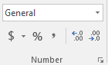
Or, you can choose one of these options:
  - Press Ctrl + 1 and select Number.
  - Right-click the cell or cell range, select Format Cells… , and select Number.
  - Select the dialog box launcher next to Number and then select Number.
- Select the format you want.

Align text in a cell
Use different alignment options to align text in a column, row, or workbook.
Align a column
- Select a column.
- Select Align Right, Center, or Align Left.
Align a row
- Select a row.
- Select Center, Align Right, or Align Left.
Align cells in a workbook
- Click a cell, or press Ctrl + A to select all cells.
- Select Left, Center, or Align Right.

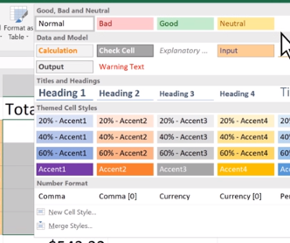
Apply styles
Apply Excel Styles to make your cells stand out.
- Choose cells to format.
- Select an Excel Style to apply.
- Select More for more options.

Modify an Excel Style
- Choose cells with an Excel Style applied to format them.
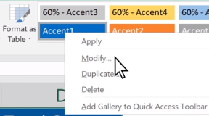
- Right-click and select Modify.
- Select Format > Fill.
- Select a color.
- Select OK > OK.

Copy cell formatting
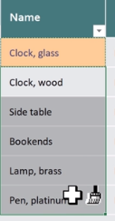
Copy cell formatting in your worksheet using copy and paste options, Format Painter, and dragging techniques.
- Choose a cell to copy.
- Select an Excel Style.
- Select Format Painter and drag to apply the Style.
Copy number formatting
- Choose a cell to copy.
- Select an Excel Style.
- Select Format Painter and drag to apply the Style.

Conditional Formatting
Conditional formatting provides visual cues to help you quickly make sense of your data. For example, it’ll clearly show highs and lows, or other data trends based on criteria you provide.
- Select the all the data in a table.
- Select Conditional Formatting > Top/Bottom Rules > Top 10 Items to see the 10 largest numbers in the table.
- Select Conditional Formatting > Data Bars, Color Schemes, or Icon Sets to see how your data can be instantly analyzed. Press Ok when done.
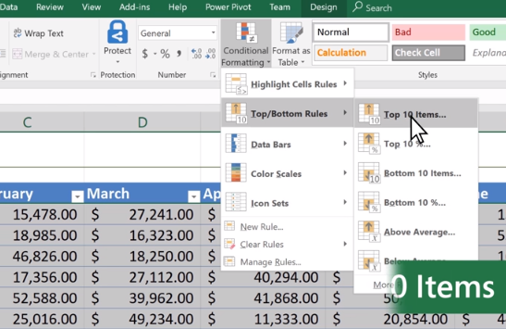
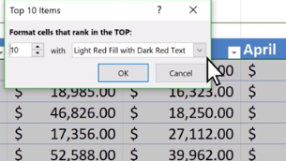

Add a watermark
Microsoft Excel doesn’t come with a built-in watermark button. But you can use an image, like a logo, to create a watermark.
- Select Insert > Header & Footer.
- Tap a section of the header and select Picture.
- Find and Insert your image. In the header, you’ll see & Picture.
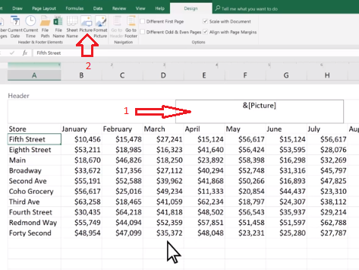
This means there’s a picture in the header. Tap anywhere outside the header to close the header and you’ll see watermark behind the data. If you don't like the look of the image or need to edit your image so it's less bold.
- Tap back into the header and select Format Picture.
- Select Picture > Color > Washout to change the look of the image. Grayscale may also work well.
- Select OK.
